# Executive Summary:

This game is based on the near future of America where president Trump has a few months in office remaining and his opposition are trying to impeach him. As the impeachment and re-election dates near Donald gets a call threatening to be exposed by using the Russians to help him get into office in the first election and has physical proof as well as witnesses to back it up. Donald responds angrily down the phone to the unknown caller and hangs up. A few months later the threats become real and the information about Donald’s use of the Russians becomes public for everyone to see. This is where the game starts.

After watching this video the players have the choice to play as Donald, Hillary and Obama. Depending on which character is chosen by the player will determine what story ark they will follow.

# Contents:

# Introduction:

## Intended Game Platforms:

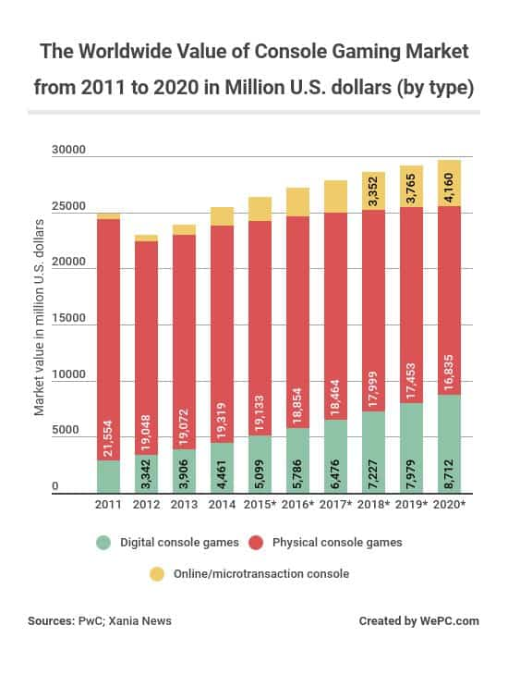The intended game systems I have chosen for this game is smartphones such as Apple, Android and windows as well as consoles such as Xbox and PlayStation. This is due to the estimated amount of players that play games on mobile as well as console being 60% as well as the mobile market global revenue being estimated at $76 billion and console revenue estimated at $30 billion this year. This is shown on figures 1-3 below

Figure 2

Figure 1

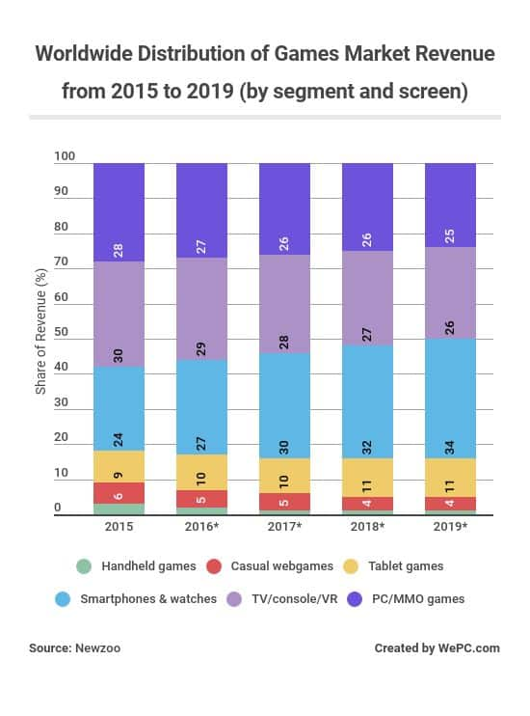

Figure 3

## Target Market & Players:

Players over the age of 16, this is due to the high amount of violence, moderate use of bad language, references towards discrimination and drug usage.

Players who are into single player 3rd person role playing games where they are allowed to customise their character and has a great story/ back story behind the gameplay. Also the genre of gameplay will be very important but I wish to try and make the game content for all types of players such as tactical, explorer and social. This game will also be funny which will help gather players who just want to mess about on games. If some players don’t fall into these brackets I will be including a lot of references towards real world scenarios which will help draw in players who watch the news as well as use social media on a daily basis.



Figure 4

## Game Logo:

Below on figure 5 is the current game logo. The idea was based on current games such has mortal combat where two of the most iconic characters face off against each other, this is also the case for movies such as Creed and Assassins Creed. For this game the three main characters are Trump, Clinton and Obama. The USA is on the background to tell the player where the battleground will be and the different clear colours are supposed to represent who’s in charge on each state.

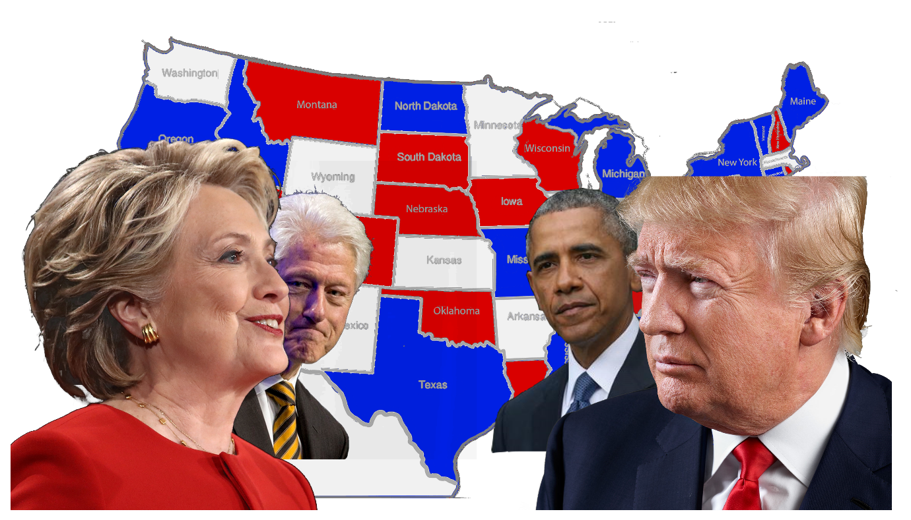

Figure 5

# Game Progression/ Flow & Chart:

## Progression System

After the player’s chose what environment to use and what character to play as they are tasked to complete main story missions, side missions and activities in each state. These missions and activities will help them acquire the majority of influence and power of that states people. Each state has an influence bar which shows the current influence to the player and the faction and rewards can be earned by the player for 30%, 60% and 80% influence from that specific state.

Players are rewarded with experience which goes towards levelling up in the game, in game currency which can be used to buy equipment from in game shops scattered across the map and equipment related to the mission itself and the rarity of the equipment earned will be determined on the players performance. They can also win armour, influence and health respective of their current traits, goals and what character they are playing as.

Players are also capable of opening loot crates of different sizes and rarity for loyal gameplay such as amount of hours played, completing several missions and activities and specifically for mobile players the opportunity to watch advertisement videos. In these loot crates players can find common rewards such as extra experience, currency and basic equipment to legendary rewards such as high amounts of experience, currency, weaponry and boosts/ buffs.

## Player Challenges

During gameplay the players will encounter several different challenges across the game world and depending on the character they have chosen to play the game as will help them decide how to deal with the current issue at hand. Players will need to adapt to each different situation and goal they need to complete in order win the encounter, this can be a main story mission, side story mission or an activity to help edge the political influence in that certain area on the players parties favour as well as earn extra rewards and buffs which will help the player directly.

Players will also have to manage the states they acquire during the campaign because if they leave it for too long they risk losing state influence and possibly the state itself (below 30%) meaning all the rewards, currency and experience earned will be taken away from them. If the player wants those rewards back or simply is a player who wants to complete 100% of the game/ achievement hunter they will have to go back to that state and complete the side missions and activities taken by their enemies. Players will not need to complete the main story mission again.

## Boss Battles

The bosses of each state or main cities are governors or political assets from enemy factions. The governors are equipped with weapons and equipment respective of the party they are with. For example if they are with Trump they will have powerful offensive weapons and if defeated have more offensive rewards over others. If the players are able to kill or capture depending on who they play as they win the rewards held by the governor as well as a major boost in state influence which could mean the player can earn more rewards. This mission is considerably harder than other missions and activities with some areas having no respawn areas meaning the player will need to start the mission again if killed.

All of this is shown in the progression chart below on figure 6

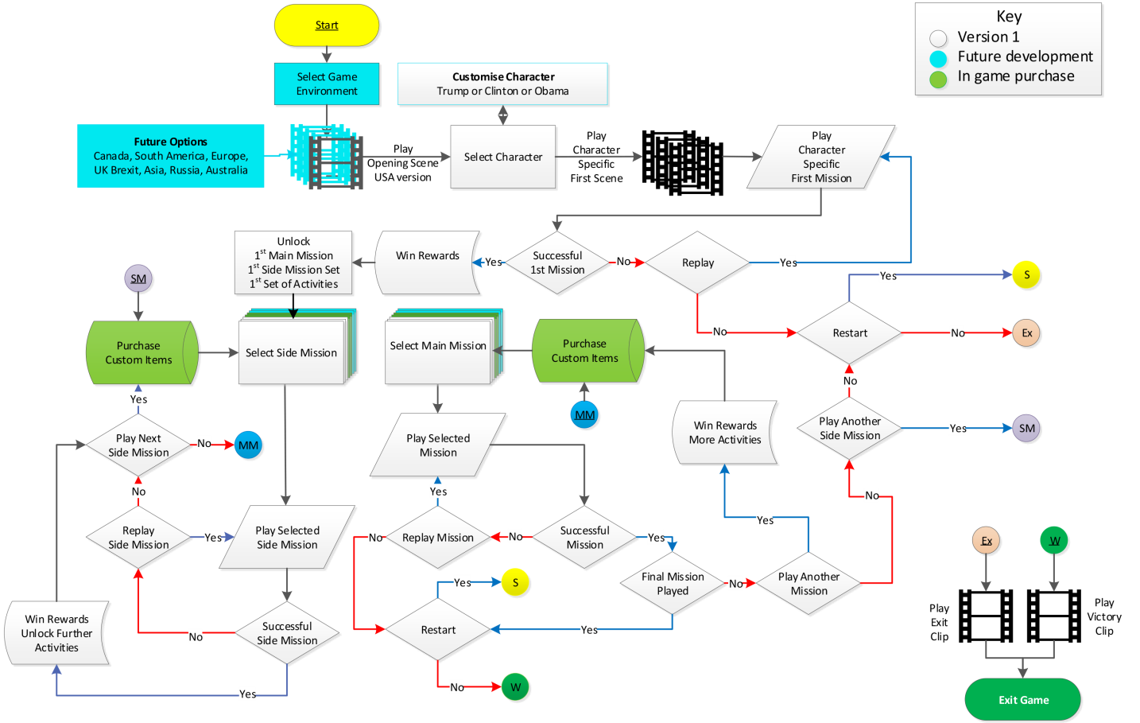

Figure 6

# Game Outline:

## Game Story:

The players will have the opportunity to play as three different political characters when they start the game; these characters are Donald Trump, Hillary Clinton and Barack Obama. All three playable characters have their own story arks and encounter each other at least once in their quest in America. At the beginning of the game the players watch a two minute opening backstory cut scene which shows them what has happened prior to the start of the game.

After this scene the players then get the opportunity to choose the character they want to play as. If Donald Trump is selected the players start by defending the white house, if Hillary Clinton is chosen the player starts as a Clinton soldier attacking the white house and if Barak Obama is chosen they start at home far away from the destruction of Washington DC gathering support and awareness.

### Backstory Cut Scene:

Donald Trump is finished taking a very long and important call which ended in some very foul language and some clear elements of anger being expressed. His family and director of the secret service ask what’s wrong, who was on the phone and what was discussed? Trump responds to his family that everything is okay and pulls the director to a private room.

Donald tells the Director that his opponents have allegations towards his about using the Russians whist campaigning for president and have witness’s as well as papers to prove this which will gravely assist in his impeachment. They have threatened to make this information public unless he leaves office immediately. Donald lets the director know his opinion on the matter and how to proceed.

Near to his impeachment court date the documents and the witness’s statements make it 100% clear that the Russians helped Donald come into power and America goes crazy and demands Donald’s Impeachment. Six Months later America in political civil war due to this matter and the land of the free becomes a warzone.

## Donald Trump’s Story:

### Beginning:

Once the Civil war starts America is divided into lots of different minor factions with different or similar beliefs on how the country should be run and by whom, the three main factions are the ones run and Barack Obama, Hillary Clinton and Donald Trump. The players are then introduced to the game world as Donald who is outfitted with a military grade assault rifle, side arm and body armour outside of the heavily damaged white house in Washington DC.

### The Defence of the White House:

The Director of the secret service approaches his and updates Donald Trump of the situation of the defence of the White House. Trump then has to lead a defence against the attackers formed of city and state militia and political opposition in Washington DC and save the defenders of likely defeat and occupation of the White House. A major battle breaks out around the premises of the white house but with the morale rallying from Donald the defenders successful hold back the attackers.

Once the battle is over Donald investigates who the attackers where, who were in command and who’s their leader. Once Donald finds out that attacked his Iconic house with force and bribery he gets all the remaining defenders of the white house and takes them to the given location of the enemy stronghold. This then leads to the first main mission of the game.

### Liberation of Washington DC

After saving the White House Donald takes his forces to attack the main stronghold and the leadership of his enemies in Washington DC. After a bloody battle the stronghold is taken and occupied by Donald and his troops. After this battle all remaining resistance towards Donald is cleaned up. Once this has all been done Donald sets his ambitions to discover recon and capture/ kill his political enemies outside of Washington.

### Middle:

After the successful operation liberating Washington DC and saving the White House Donald turns his interests in neighbouring states and cities. Using his forces acquired in the cities and towns of Maryland he states his campaign to attack and acquire the states of West Virginia, Virginia, Pennsylvania and New Jersey. Capturing these states and their resources he though would be ideal to intimidate any further resistance in nearby states and cities, forcing them to join him rather than fight.

### Early Successes:

In Donald’s early campaigning for support and occupation of neighbouring states and influential cities have been very successful, Donald starts to get very confident in his chances of power in America once again. He places his most loyal commanders and representatives to keep the required lands taken from him. These successes make minor factions join Donald’s army without a fight due to the size and the fear of being killed. He adds them to his ranks but does not treat them as well as his own troops as well as being highly considered to do battle against his enemies first, these minor factions are not too happy with this but their alternative is to be destroyed next.

### Rapid Expansion:

Donald continues his expansion across America taking his army equipped with the latest equipment available from the military and other sources destroying, occupying or recruiting everything in his path. During his campaign more and more smaller factions, National Guard, Police and militia join his cause leaving small forces behind to keep the occupied land under reasonable control, this is a secondary goal for Donald as he will worry about the populations happiness after he’s satisfied with the land he has acquired. However due to campaigning Donald starts to run out of loyalists to keep his territory under control forcing him to have to negotiate treaties allowing the defeated leaders to keep their strongholds.

### Political Decline:

Due to the matter of the lack of loyalists his army’s majority made up of smaller factions and mercenaries start to have their heads turned and go against Donald. These thoughts are discussed between the leaders of these armies in secret meetings in disclosed areas to prevent being detected. Donald starts to see posters and advertisement towards his past which causes his troops to start to reconsider their alliance with him. He rips down all these posters in anger and demands loyalty from his soldiers, allies and mercenaries; however these armies’ integrity and loyalty starts to waver.

### Major Defection of Allies:

Once the seeds of doubt entered Donald’s armies he, his loyalists and advisors do their best to keep their integrity so they can continue with the expansion campaign but they were fighting a losing battle and eventually all his armies and land that are run or led by purchased loyalty or ineffective allies defect against him and join either Clinton, Obama or break off into their original factions run by themselves. This really puts a massive setback to Donald’s campaign causing him to go to his advisors and loyalists to come up with a plan to take back these lands and what will be required to do so.

### Plans to escape America:

Donald creates his plans to retake lands from the defectors and what resources will be required to do so but also not ignoring the main enemies of Clinton and Obamas factions. After some attacks and recapturing of states and cities Donald finds himself fighting on their fronts with limited troops and supplies so he is advised to strategically withdraw from his campaign and escape from America via Mexico until his enemies weaken each other.

Donald knows if he stays and fights he will almost certainly be defeated and tried for crimes against the American people but if he leaves America he can come back with any remaining loyalists to destroy his weakened enemies and take over once more. He then leaves with a small squad to avoid detection.

### Loss of remaining allies:

Whist Donald and his squad move towards Mexico a large scale assault run by Clinton, Donald’s defectors and smaller similar interest factions attack the remaining lands of Donald’s allies, kill them all and capture his wife and kids. He is informed over a nationwide radio station.

### End:

Donald is able to get into Mexico by bypassing the wall defended by Mexican border police and National Guard where he bribes his way out of trouble and lives the rest of his life under the protection of the Mexican drug cartels with his family which are released from political prison after an agreement was made with the US to never come back and in return he will get his family back in Maryland.

## Hillary Clintons Starting Story Ark

### Beginning:

After hearing of Donald Trump’s tampering of the previous election and the proof being validated by the sources providing the information and the witness’s confirming everything being shown to the world Hillary wakes up her husband Bill and immediately started plans to overthrow Donald in Washington. During the six months that followed Hillary and Bill planned an attack on the White House to try and quickly kill Donald and take over the country. They both recruit a mercenary group and citizen militia with basic weapons and gear to attack the White House using Guerrilla tactics.

### The Attack on the White House

After recruiting the small army, Bill Clinton provides information to the militia of secret pathways/ passages into the White House as well as predicted places where not to attack due to the number of forces, this information is given to them when Bill was in power in 1993-2001 so the information arguably is outdated. Nevertheless the small army took this information and assaulted the White House using a nearby stronghold occupied by Clinton enthusiasts. From this stronghold the Clinton strike force which the player a part of will attack the White House severely damaging it which forces Donald Trump to come out of hiding. Clinton’s forces report sightings of Donald and on Clinton’s orders to attack him. These results in defeat and a full scale retreat for Clinton’s forces back to the stronghold.

### Loss of Maryland State:

After hearing of the defeat and full retreat of the Clinton Liberators Bill and Hillary’s orders where to gather as much support as they can and defend the stronghold until Bill can come with an massive army to reinforce and take out Donald and his White House forces for good. Unfortunately it was too late so Hillary’s orders where to fight to the last man & woman whist taking out as many Trump supporters as they can. After Donald killed the remaining Clinton influence stationed at the Stronghold Bill gets a call from Donald declaring war on them.

### Middle:

The Clintons get word that Maryland has been lost and Donald is preparing to expand rapidly across nearby states and cities. Hillary and Bill call their assets and allies to prepare to fight. They also know any raw materials and resources provided by those areas are going to be under major threat meaning they will need to acquire these resources elsewhere and fast.

### Early decline in power:

In the early days of the campaign states and cities are falling at a high pace to Donald and his forces. This installs fear into Hillary’s smaller armies and allies across the country causing some to break allegiances with her and all other agreements such as trading weapons and soldiers for her campaign. This forces Hillary to go out and recruit new minor factions and mercenaries but there effectiveness is affected by the ongoing situation.

### Coalition between states:

Hillary and Bill get word that Donald is starting to slow down in his advance across America so they attempt to agree with themselves and any remaining minor factions of similar interest to band together to stand a chance to halt Donald’s advance and possibly defeat him and his armies. Everyone agrees and turn into one major faction with the goal of killing Donald and get back the lands taken by him.

### Expansion plans:

At this time all three factions have started the propaganda war to try and recruit as many allies with different traits to their side. Hillary and Bill start to plan a mass scale campaign to destroy, subjugate or ally with any forces remotely against Donald’s rule, with the goal of merging all of America against Donald and killing him. At first they have issues with planning due to the amount of new allies they have who have different ideas and means to tackle this problem. Hillary has a meeting with all the leaders of the factions to discuss what to do next and how to do it. They all agree with propaganda methods to start.

### Propaganda Advertisement:

Hillary, Bill and the allied leaders create posters, social media posts and radio recordings to spread the word of how they will defeat Donald and his rumoured unstoppable forces. They create posters with his past actions, the letters and statements teeing him to the Russians and what America looks like on the streets right now. Their goal of doing this is to try and reach out to the Armies under Donald which at this time are reconsidering sides; they just need a solid reason to defect. After a little while word gets out that Donald’s armies are defecting at an uncontrollable rate, causing Donald to stop advancing and fix his internal problems. This is a perfect opportunity for more recruits.

### Enemy of my enemy is my friend:

Hillary and Bill learn that the defectors from Donald’s lands the majority have created a coalition and become the separatists. They call a secret meeting with this new group and propose to join forces to attack and finally defeat Donald and his remaining forces across America. After much discussion they agree to join together to defeat Donald meaning that Hillary becomes the most powerful faction to take over despite alliances being made for one sole reason.

### Destruction of Donald’s allies:

Hillary and Bill plan for the major scale assault on the remaining loyalist states and cities of Donald in Maryland, nearby areas and states. As they swiftly gain victories over Donald’s strongholds and cities there is no sign of the man himself, the Clintons believe he’d be hiding back at the White house so they keep on advancing but lose support from a few faction leaders due to them wanting there lands back and nothing more. Bill and Hillary are okay with that as long as they kill anything to do with Trump meaning no prisoners.

Soon they reach the white house where Donald’s last remaining forces are preparing to defend for what little is left, a massive battle plays out. Hilary’s forces win using the knowledge of Bill of the white house such as secret entrances and back alleys but still cannot find Donald himself. A soldier finds the secret service director and his family hiding in the underground bunker. They inform Donald over a nationwide radio channel that they have his family and to stop hiding. The director also is forced to tell them his plans to escape to Mexico, the chase is now on.

### Killing Donald (End):

Hillary and Bill trace back the footsteps given to them by the now deceased director to find Donald. As they follow him they find small pockets of resistance either loyal to Donald or purchased but they don’t have time for negotiations to they are killed. Eventually Donald is found and along with his family executed for crimes against America. This means that they have a clear road to Washington and the Presidents seat, the only main opposition being Obama’s party wo aren’t interested in fighting, they just want to stop the war.

## Barak Obama’s Starting Story Ark

### Country Divided

After hearing of Donald Trump’s tampering of the previous election and the proof being validated by the sources providing the information and the witness’s confirming everything being shown to the world Barak Obama scoffs/ giggles to himself saying he knew it and America is salvageable from his rule. He then tells his wife and kids what has happened and he is going to make a few calls inside Donald’s party as well as party representatives who have resigned or been fired by him. During the next six months Obama calls and meeting with all these politicians and influencers across all of America to start a revolution to save America before it’s too late.

### Saving America

Barak and his wife Michelle make it clear to his allied Politian’s, civilians, mercenaries and soldiers that they do not want to try and find a fight with the opposition but to primarily help wounded during battles and the helpless, almost acting like liberators to try and influence nearby cities, states and its people to the reside through kindness, healthcare and protection rather than brute force and death. Barak’s goals are to save America, not to destroy it in an attempt to kill is opposition. He and Michelle make that very clear to anyone; city and state hat want to join their cause. In the event of capturing an enemy stronghold or major influencers his soldiers are under neutral orders to bring them in for questioning and the opportunity to keep their lives in exchange for information.

* Doesn’t like fighting
* Wants to bring back Donald took away
* Free healthcare
* Capture Donald and Hillary
* Dirty work done by allies and loyalists
* Doesn’t want to know about fights just wants to know results
* Great negotiator
* Brings people in need across America into his protection

**Can’t think of a story for Obama**

### End:

Barak and Michelle manage to convince any surviving members of both Clintons and Trumps armies to lay down their arms and live together without any more destruction and death of the American people. As they campaign across America armies, militias and even mercenaries stop trying to kill each other and resolve these issues diplomatically rather than violently. As a result of this Bill, Hillary and Donald and exiled to Southern America where they just have their wit and will to defend them.

# Game Characters & Traits:

## Playable Characters (PC’s) & Traits:

### Donald Trump:

Donald is a very aggressive and outspoken character meaning that he doesn’t get along with a lot of people and can easily upset others; however he is a very successful business man meaning he is able to make a lot of deals for man power weapons and resources. He is also capable to bribery towards enemy forces; however loyalty in the long term can be hard to keep.

Donald’s Traits:

* Very aggressive
* Outspoken towards others below him
* Discriminative towards others, especially skin colour and nationality
* Successful business man
* Capable of bribery and poor loyalty from purchased allies
* Access to presidency perks such as secret service soldiers

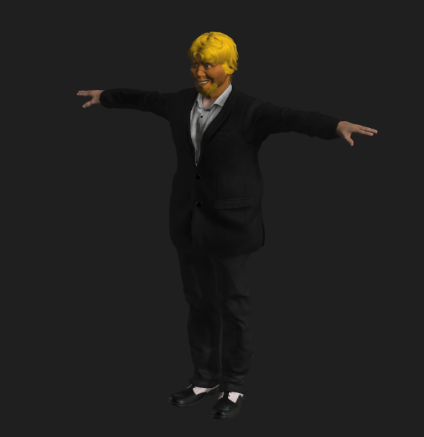

To the left is the body of the first build of Donald Trump’s character, he is very well dressed with his suit and shoes as a default design which can be changed by the player under character customisation at any time. To the right is Trump’s Faction flag, this will be help by trumps allies, hung up at Trump held fortified areas and strongholds on free roam and shown on the game map to represent his control of the state or main city.

### Hillary & Bill Clinton:

Hillary & Bill are just as aggressive as Donald but they are aggressive in a different way, they use it politically to encourage other strongholds to yield rather than fight as well as get some support from superpowers abroad. This means they don’t have as powerful weapons as Donald’s allies but have access to more variety of weaponry and forms of weapons such as armour and deployable equipment like turrets and drones. She also has the knowledge of the country given to her from Bill when he used to be in power meaning she can find collectables and secret entrances to some areas.

Hillary and Bills traits:

* Politically Aggressive towards enemy positions
* Minor Influence Abroad
* Negotiation skills
* Access to rare armour
* Access to deployable equipment
* 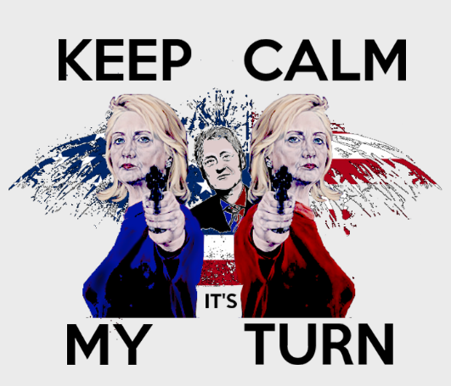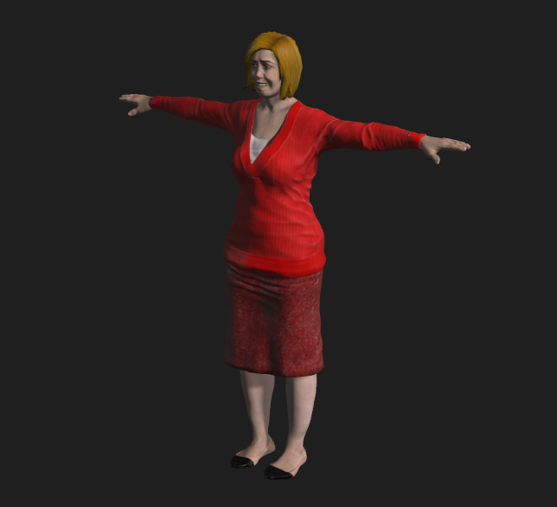Can find secret entrances and collectables

To the left is the body of the first build of Hillary Clinton’s character, she is in a very respectful dress and work heels as a default design which can be changed by the player under character customisation at any time. To the right is Clinton’s Faction flag, this will be help by Clintons allies, hung up at Clinton held fortified areas and strongholds on free roam and shown on the game map to represent her control of the state or main city.

### Barack & Michelle Obama:

Barak and Michelle are not nearly as violently aggressive as the Clinton’s and Donald’s supporters but they do have the support of the healthcare aspects of the country as well as very strong skills in negotiations as well as caring for fallen and wounded enemies. This means that Barak hasn’t got access to very powerful weapons but have a lot more health in battles as well as access to deployable health assets to help allies and extra resource, weapon and other loot based missions or areas across the map they can take.

Barack & Michelle traits:

* Standard weaponry, strong survival skills
* Very strong negotiation skills
* Willing to help any American regardless of beliefs
* Deployable health assets
* Extra resource based missions
* International relations with other superpowers

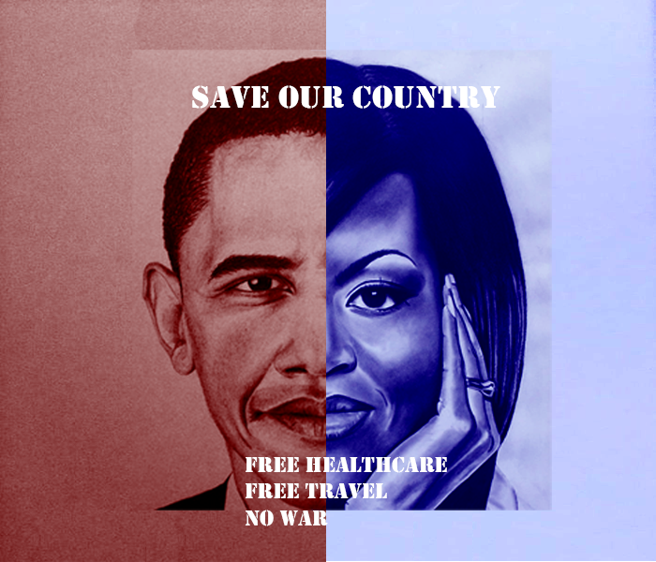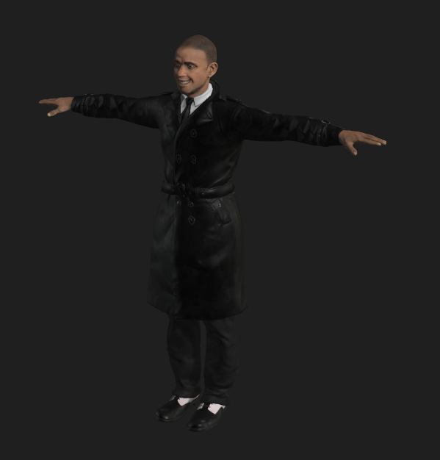

To the left is the body of the first build of Barack Obama’s character, he is in a suit overcoat as a default design which can be changed by the player under character customisation at any time. To the right is Obama’s Faction flag, this will be help by Obamas allies, hung up at Obamas held fortified areas and strongholds on free roam and shown on the game map to represent her control of the state or main city.

## Non-Playable Characters (NPC’s):

### Secret Service:

The secret servicemen and women are the president’s personal army equipped with high tech, powerful and modern equipment. They are capable of defending strongholds very well but due to the lack of armour and direction they are not recommended to be used for assaults. They are also very expensive to recruit and can only be recruited by the presidents character (Donald Trump). They are able to be recruited from anywhere and can provide Donald great cover for his escape is necessary.

### City Based militia:

City based militia can be found in major cities across America where they class themselves as their own independent militia from the state they are in. these militia can consist of standard American women and men, retired police officers, non-professional soldiers and defected soldiers/ people. These soldiers are perfect for the player’s character to hold to strongholds in cities and states captured during gameplay.

### State Based militia:

State Based militia are exactly the same as city based except they have a more variety of recruits and can be called upon when the player is assaulting an enemy stronghold/ base in the state they are in.

### National Guard Soldiers:

National Guard soldiers are dotted around America in their base of operations. They can be called in to assist the player at any time but depending on how they are influenced in that state/ city against the player to quicker they will arrive to the players position as well as the number of soldiers in that squad. They will be armed with military based weapons which can help the player a lot against the likes of a Donald Trump stronghold.

### American Police:

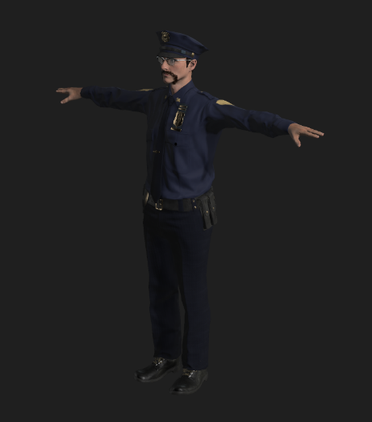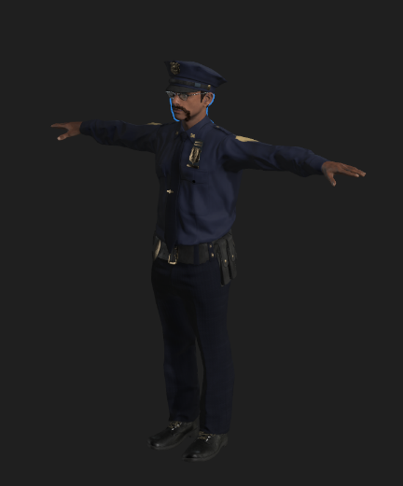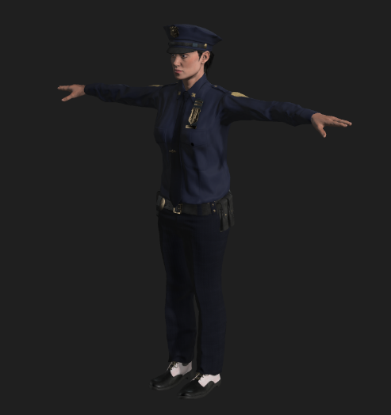The American Police are not that much more powerful to the militia but they are very well organised and when called/ recruited by the player to help they are most effective in street battles and door to door raiding. They are also relatively cheap units and can be very effective in numbers. There main weakness is the secret police and National Guard Units.

### Mexican Border Police:

The Mexican border police are all based along the wall that Trump has built to separate America from Mexico. They are all heavily armoured with strong weapons and very hard to negotiate with. However they will never venture into America and also have some lightly guarded areas across the wall that the players can exploit in order to win as Donald. If the player wishes to try and shoot their way through they will need a lot of followers and weapons to do so.

### Mercenaries:

Mercenaries can be recruited by any player at any time for a cost in influence o/ and currency. The players can be anywhere on the map to purchase them to help fight battles offensively or defensively. The drawback to these soldiers is they are mercenaries and can be bought out by your opponents before or during a battle causing the player to have to fight them too. To help prevent this they have traits and if their loyalty is low the player’s suggestion is to not purchase them.

**Include base character from Adobe Fuse**

**`**

# Player Character Customisation

## Beginning of the game:

At the beginning of the game the players get to choose one of the three main characters, once they have done that they can visually customise their characters clothing. The players will have access to all sections around the body (upper, middle, lower body and feet). Players can customise their character to personalise it to themselves. They won’t be able to change any facial or body features till later into the game and can be earned as a reward for missions. These features are shown to the player as “locked” so they cannot be selected.

On the customisation menu screen they players can distinctively tell which type of clothing is where by showing them different icons relating to the clothing section they chose. For example an image of hair is hair, glasses are facial accessories, shirt is upper body and trousers are lower body. They can also change the colour and design of the clothing items they chose after progressing past the clothing selection menu. The new features can then be applied to the player’s character in the pause menu once earned or bought. The icons are shown on the right on figure

Upper Body Customisation:

* Selection of hats
* Selection of scarfs
* Selection of Glasses

Middle Body Customisation:

* Selection of Shirts
* Selection of Jumpers
* Selection of Jackets
* Selection of Bags/ Handbags

Lower Body Customisation:

* Selection of Trousers
* Selection of Shorts
* Selection of dresses & skirts

Feet/ Shoes Customisation:

* Selection of high heels
* Selection of trainers
* Selection of boots and shoes

## During walkthrough of the game:

During the game players can earn the features and clothing locked to the player at the start of the game. They can do this by completing side missions or activities given to the player by NPC’s or by clues such as audio recordings as articles found in main missions or free roam. Once the player completes the mission/ activity they will unlock that feature and if they wish can change their character appearance on the pause menu. These rewards include the colour of the features such as hair and eye colour as well as clothing and accessories.

The customisation of the character does not given any buffs, traits, advantages or disadvantages for the player’s character, this is simply to allow the player to personalise the character.

# Gameplay:

## Sequence of Play after intro:

Once the players have completed the introduction levels to the game they are then introduced to the rest of the game world where there are lots of different cities and states under different influences and beliefs. They are then guided to the next state and depending on who the player’s character is will determine what the next mission is. After the completion of the first mission or activity the player unlocks several more side missions and activities to complete. The state or city tells the player there are a number of these missions that need to be completed in order to progress through to the main mission and storyline. This method is to help encourage players to do side missions and activities during free roam.

From here it is then the player’s choice where to go next and in what order they complete the side missions and activities across the map. Players have the opportunity to earn rewards from these missions depending on their difficulty and what they must do; rewards are also determined by the enemies they have to fight. Players can only complete the main story missions in a linear order, it doesn’t matter where the main mission is played.

## Different Scenarios:

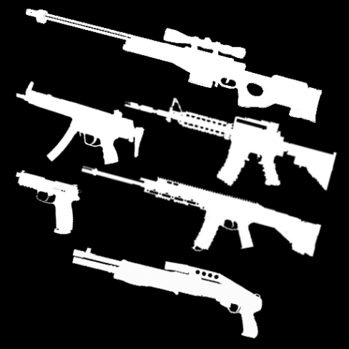In the missions and activities the players won’t always be killing enemy/ shooting related, due to the nature of the game scenery there’s elements of survival required for the player’s allies to concentrate on too. Depending on whom the players character is will help determine what missions they are recommended to complete. Survival missions will include scavenging for resources, finding and stealing from convoys, looting abandoned areas, research/ discovery, intelligence gathering, exploration, negotiation and propaganda. All of these missions and activities helps the player gain control of the city/ state and earn bigger rewards. There are also areas of interest where the player can find resources such as medical, equipment and clothing without having to earn it.

## Collectables & Pick Ups:

During walkthrough of the campaigns the players can come across collectables such as intelligence and articles that help the player understand the backstory to the game (years of 2016-2020) and what happened in these years as well as predict enemy movements. They can also find custom items specific to the character they are playing as for example spray tan for Donald trump and goggles for Hillary Clinton, these items cannot be earned by can be bought in the in game store.

To the players find these items they will be guided visually and with clear distinct sounds. These items will be ringing constantly much like a phones ringtone as well as highlighted in a primary colour making it clear to the player when found. Below in figure () is an example.

These items will also be labelled on the players HUD to what the item is or if it’s a randomised it will displayed as a crate with a clear design or label to make it clear to the player this is a collectable. Below in figure () is an example.

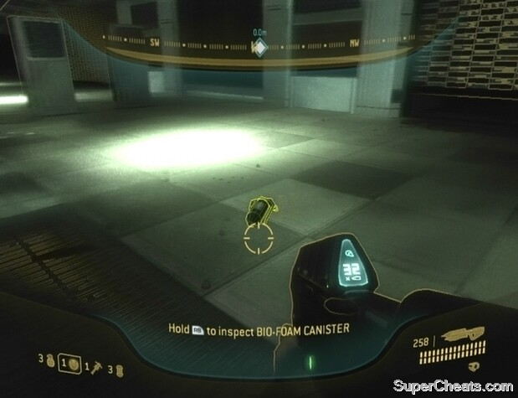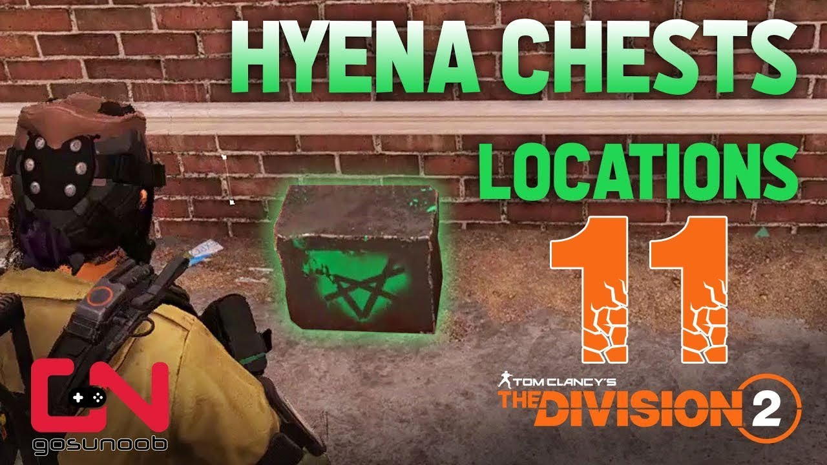

# Game World:

## Game World Map:

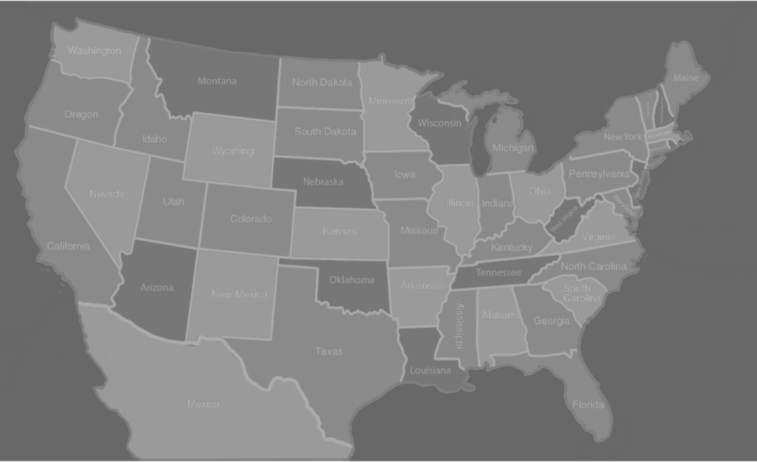The player’s world map will be located under the pause menu during gameplay. The players Character will visualise this action by looking down onto his wrist watch. Once the map has been selected they will be in a bird’s eye view of their current location and the nearby settings/ environment. Using the left joystick or left mouse click the players can then move there cursor around the explored areas of the game world and can set destinations to missions, activities or any area of the map they wish to go to. They can also use the right joystick or middle scrolling button on the mouse to zoom in and out of the game world to help the players find more activities or missions to do in order to earn enough influence in that state/ city to progress. This also helps provide some opportunities of exploration.

## Features of World Map:

There will be several different features for the players to discover, understand and strategize whist progressing through the game. The three main features to look out for are the players political rivals last known location/s, position of missions and what their requirements are to unlock and lastly the influence in each state and city across America. The players can then decide what they would like to do with the map information provided to them.

Using the map the players can try to discover where there political rivals are within the game by completing Intelligence and research/ discovery side missions and activities. These missions will help the player discover and unlock sections of the game world before their political enemies. They can also use the map to see where new missions and activities have been unlocked due to successfully completing previous missions and activities.

Using the map the players can learn the political status of nearby states and cities so they can learn the amount of work that’ll be required to obtain the state or city so they can earn the rewards. Some states may be leaning towards the player’s character politically meaning they have to complete less missions and activities against easier opposition. This also means if a player wishes to acquire a state or city that’s politically against his character they will need to complete more missions and activities against harder opposition. However if the players leave a state or city unattended for too long they could lose power therefore the rewards it brings, meaning the player has to go back to get the state or city back before progressing. Below is examples of icons showing what rewards are available and map locations.

## Environments and Locations:

The players will have to travel across all of America especially playing as Barack since his goal is to save America so undoubtedly the players will have to explore different environments, these will include dessert, rural, overgrown/ forests, mountainous/ snowy and sparse locations across America. In these different areas the players will need to adjust to the scenery such as what weapons, armour and explosives. Also is all these environments there will be elements of destruction, poor sanitation and maintenance due to the nature of the game. This will help the players adjust to similar scenes and environments they may encounter during gameplay.

## Story Related Locations:

During the main story of each other the characters campaigns the players will experience every different type of scenery in the game at least once so they can experience the environment and have the opportunity to admire and learn how to fight in this type of environment. Each different type of location will be tied into each other with the use of intelligence reports and collectables found during each main mission, one or two being guided towards so the players cannot miss it. This also allows the players to understand there character a lot more and what happened to America pre-civil war. This then leads onto the next main mission in wherever the audio footage suggests the player to go to.

In some of these locations there will be elements of the past shown such as locations for Donald’s Rally’s and what people thought of them through these intelligence findings. Having the players understand what the character has done in each location the main story takes them will invoke what moods they have towards their character and why depending on who they are playing as everyone wants to murder him/ her or support him/ her within the game.

## Character Specific Locations:

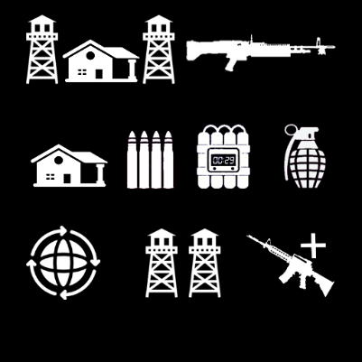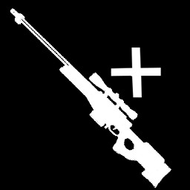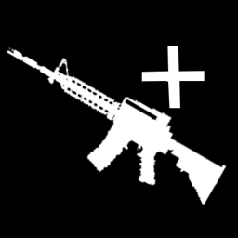Character specific missions and activities all relate there the player characters traits when they start the campaign meaning they can develop their advantages towards their enemies to help give them an edge in different scenarios. Donald’s being weaponry has access to light machine guns (LMG’s), Hillary has access to superior explosives and armour equipment and Obama has superior medical supplies and political skills worldwide.

## Things found in Different Environments:

### Desserts:

Desert Vanish, Living Stones, Acacia Trees, various types of Cacti and rocks, Barns, gates and fencing

### Rural:

Selection of storage objects, living luxuries, vehicles, buildings and construction, newspapers and magazines, seating areas, gardens, bins, bollards, lamp posts, pathways, roads, bridges, boats

### Overgrown/ forests:

Various types of trees, poisonous plants, tree trunks, ponds and rivers, rocks, leaves, waterfalls.

### Mountainous/ snowy:

Rocky surfaces, rocks and boulders, stripped down trees, snow, manmade pathways, and ridges.

### Sparse/ low populated:

Farmland, gates, fencing, barns, cottages, lakes and rivers, plantation, vast open spaces.

# Audio/ Soundtrack Features:

## Character Speech:

Character audio is dependent on which character it is and what scenario the character is in at that specific time in the game. There’s going to be a lot of swear words and other forms of bad language being used by the players character during bad scenarios, when the character is wounded and near death. There will also be positive audio being used by the player characters such as winning a battle or seize of an enemy stronghold.

Player characters will also have good comments of audio when something goes there way such as successfully defending a stronghold or killing or capturing a main enemy during the campaign depending on who they’re playing as. These comments don’t have any political consequences towards the characters position; it is more to add to the feel of a battle environment for the player.

Characters will also have small comments when they rank up during the game to emphasize the levelling up, also players can unlock different comments to then be used during different scenarios across America. If the players do not wish to earn audio features they can buy it in the in game store.

## Different Scenarios/ Winning or losing:

During gameplay the player will encounter different types of scenarios and requirements to complete/ escape that scenario. Players will be given clues with small soundtracks on where to go or avoid. During main and side missions is where most of these sounds will be heard, they will be heard during boss and specialist enemy encounters, saving allies/ saving a friendly stronghold from assault. They will also be used during discovery and exploration missions to help the build-up of the situation the player is in.

When the player loses a side mission or activity but hasn’t died due to it such as a propaganda or convoy hitting activity they will be defeat type soundtracks and audio to try and get the players to try again. Once players win an activity or mission they will be greeted with completion type audio soundtrack whist there rewards are being given out on their HUD/ screen.

### Weaponry:

There will be different types of audio fitted to different weapons which the player has access too such as handguns, SMG’s, Assault Rifles, LMG’s, Handguns and Snipers. Also the audio of the player switching a weapon or deploying a weapon will be heard too. Handheld explosives such as grenades will have distinct different sounds depending on what type of grenade it is. Attached explosives such as C4 or Dynamite will have a much bigger and louder explosion soundtracks especially if you’re playing as Hillary and complete a successful explosives mission.

## Environments:

As stated before there will be several types of environmental settings included in the game with different types of rewards based around that area such as shotguns being mostly earned in southern America. This is to help encourage the player to explore the different environments and adjust to the scenery they see. The different environments and the audio what will be included are shown below:

### Desserts:

In this environment the player can expect to hear a lot of dry wind taking sand and rock with it, the rustling of very few plants and the sound of nothing to peak the players curiosity. Having very little sounds in these areas are designed to keep the player alert and the suspense high.

### Rural:

In these environments the player can expect to hear a lot of man made noises such as weapons being fired, construction related, weather related and the wildlife that live in the city such as birds, dogs, cats and mice/ rats. They’ll also be sounds coming from vehicles such as car horns and shutting of doors or windows. They’ll be a lot of explosions too.

### Overgrown/ forests:

In these environments players can expect to hear a lot of wildlife living in the trees and bushes as well as a lot of wet wind and rain to go with it. The weather can be harsh and unpredictable in these environments.

### Mountainous/ snowy:

In these environments players can expect to hear a lot of cold wind as well as a lot of snow and ice distracting the player. There will be quite a lot of forests in these environments which also brings here audio too.

### Sparse/ low populated:

In these environments the players can expect to hear very little expect a lot of wildlife living in farms and occasionally extreme weather conditions. There may be some sounds of manmade fighting too.

### Collectables/ Intelligence:

When a player is near a collectable during free roam or a mission they will hear a bleeping sound and as they get closer to the collectable the bleep gets louder and louder until they find it. This bleep also get quieter as they move away from the collectable, this to indicate to the player they are going the wrong way.

# Game Experience:

## Player first impressions:

When the players choosing their character, customising him/ her and finish the first two introduction levels they will witness a political civil war which has completely divided America and turned it into a war zone. As they witness for the first time the destruction of America I want the players to feel sadness towards the people and no hope there is to prevent or stop another major political war from happening. I also want them to feel frustrated and angry for what has happened whist being determined to fix everything during gameplay throughout the game. I also want a small amount of laughter and humour for towards the character choice they have.

## Development of the Player Character:

Depending on whom the player choses at the beginning of the game will determine who they empathise with. I want players to empathise towards the American people despite which side they have taken due to their great nation is in the state it is in due to politics. I want players to understand there character as well as the others through intelligence and collectables during gameplay and let them decide to be empathetic towards.

As the players progress with their character I want them to understand why the enemy is there enemy and what they could do if they were the character in the game and how they can fix what has been broken. I want the players to feel a sense of urgency towards their main goal in the game to save or escape America.

## Story Cut scenes:

At the beginning of the campaign there will be a backstory cut scene which sums up what happened just before the 2021 election and describes the foundations to why America is in its state. The players will then witness how their character reacted to the news that was made public to them just before the election campaign started.

During the game players will witness short cut scenes where there allies in captured or occupied strongholds ask them for help towards a situation, giving information to the player or being made aware of resources. With this information the player can then chose to help, gather or look into the information given.

Main story cut scenes will be much longer and will be shown to the player as they progress through the main story-line of each character. These scenes can also be acquired through gathering intelligence found around America but won’t be as long nor significant to the main story.

## Game Presentation/ Packaging:

**Create Photoshop doc of game case for XBOX, PC & PlayStation, include the front and back**

**How will your game be presented to the player from the beginning (game packaging/ cover) (look at DVD cases)**

**Describe anything about your gameplay that will get the reader excited**

# Gameplay Mechanics:

## Core Mechanics:

### Movement:

Walking and Running to get across the map to get to a desired location/ destination due to there being no form of public transport such as trains or busses as well as private transport such as cars and vans. They’ll also be jumping and sliding over objects and manmade explosives or avoid natural hazards.

### Weapons:

Aiming, shooting, reloading and throwing will be required to have a weapon with them at all times and have to be ready to aim and shoot anything whist making sure they have enough ammunition to venture outside of the allied strongholds and throw explosives such as grenades at enemies.

### Combat:

Rolling and going behind cover must be used if the player’s character is getting low on health and is near death, can be used to avoid certain weapons such as rocket launchers. Deployments and Reinforcements to be able to use the special abilities which the character has and the players can use to increase their chance of success

## Interacting Mechanics:

### Elevation:

Ladders and Ropes to be able to climb up and down to reach different floors or platforms of buildings. Platforms to jump onto to get to different levels on a building to gain an advantage.

### Collection:

Collecting loot crates and pickups to open or stolen from other factions across the map as well as opening audio and visual intelligence found. Also being able to pick up ammo, explosives and weapons from dead enemies.

### Communication:

Being able to communicate with allies in allied as well as enemy territory, also to talk to NPC’s in need of help or has information which can help your main goal in game.

## Economy Mechanics:

### Game currency:

Players will be able to earn in game currency for completing missions and activities, they’ll earn bonus currency depending on their performances. Currency can also be earned from loot crates found or earned during the campaign.

### Trading and selling:

Store and shops will be present in areas the player has control of and will be found in stronghold or fortified areas. They can use the in game currency to purchase different types of equipment such as weapons and armour and equip to their character. They can also trade equipment they already have and don’t want any more to get discounts on equipment they want from these stores.

## Encounters:

### Manmade:

Manmade traps/ hazards such as tripwires, explosions, motion trackers, alarms which the players are recommended to avoid o they are not detected

### Natural:

Naturally made such as sink holes in deserts, the tarmac due to poor maintenance and forest due to ponds and rivers. Overgrown areas causing limited visibility and broke off vegetation such as logs crushing them as they fall from hills.

# Multiplayer & Bonus Material:

## Achievements:

### Performances:

During gameplay the player will be able to unlock achievements during missions and activities. They’ll be able to get them for having an outstanding performances. These achievements are aimed towards players who want to get all the achievements in the game.

### Character Change:

Some achievements can only be achieved by using a specific character in the game, this will help encourage players to replay the campaign as different characters. Players will be notified when they complete an achievement with a notification on their screen HUD and if opened with a description what they have done to get it, this is for the players that don’t know how they got it.

## Bonus Material:

### Equipment:

Player’s performances in missions and activities will give them a selection of blueprints they can earn, after enough are collected they can construct the legendary equipment or weapon they’ve been trying to get. Alternately they can complete missions or activities and keep replaying them to earn currency to then buy it in an in game store. These weapons will be worth at a huge amount of in game currency causing the player to consider spending real money for it.

### Replay-ability:

When a player has completed the campaign and want to pay again they will have the opportunity to import there characters rank, weapons and currency so then they can continue to rank up their character as well and improve their equipment and weapons by playing the same missions. Also importing there character gives them the opportunity to play missions and activities that didn’t exist during the first walkthrough. This is to stop the player getting bored during gameplay.

## Multiplayer:

### Campaign:

The main multiplayer aspect of the game will be co-operative or competitive campaigns. This is where the storyline goes to the side-lines and the player’s campaign through America to beat one another or beat the AI playing as the enemies. This means the likes of Donald Trump and Hillary Clinton can be allied against Barack Obama and other small factions in America.

# Monetization:

## In Game Store:

### Currency and Buffs:

Players will have the opportunity to purchase in game currency and boosts or buffs which will help them purchase whatever they want in an in game store or give them an edge in certain missions. These will be a very cheap, around £2-5 but aim to sell it to several player on more than one occasion.

### Equipment and Weapons:

If a player wishes to not grind on the game for hours and hours in order to earn the rewards to get a legendary weapon or equipment they will be able to purchase it instead. These items will aimed to cost £5-20 depending on the weapon they want, how rare it is, what they player has to do in order to earn it and the rank they have to be to get it.

### Customisation:

Player Characters customisation at the start of the game are mostly locked but as the player progresses they will be able to earn more clothing items to include on their character, however if the player does not wish to wait they can purchase clothing items for a small to a high price of £3 to £15 depending on what the clothing item is and if they are getting a bundle deal.

There will also be seasonal customisation assets available for the relevant time of year such as a Christmas hat over the Christmas period. These can then be purchased by players after the seasonal holiday if they didn’t get it. Players can also buy the characters special pick-ups such as goggles and spray tan rather than trying to find it in gameplay.

## Downloadable Content (DLC):

### Environmental:

On the main menu players will have the option to play in different world scenes or environments as well an all new roaster of characters to choose from and a whole new storyline. For example playing as a Cartel in South America with each opposing cartel having different goals to export there goods or a Brexit scene where players can run for prime minister and try to bring Brexit through in Brussels. This will be a campaign extension costing around £15, this is to try and keep players playing the game and not get bored.

### Characters:

Players will have the option to purchase different political characters and storylines to follow in the main campaign in America. These characters will relate to the other minor parties across America and there goals will be much harder to reach, this is to try and add some challenge to heavily experienced players. Players can also purchase characters from the same parties as Donald, Clinton and Obama such as Michelle and Bill. They’ll follow the same storyline but with these characters.

# What additions to include:

* **Project Report (very short what I wanted to achieve with my prototype & if the artwork created is yours or used from 3rd party sources)**